You can donate by using Church Center on your computer or your phone! Here’s how:
1. Giving Using the Mobile App

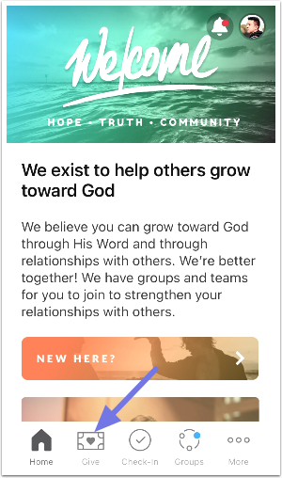
To give via the mobile app, log in to Church Center, then tap the Give button to access the donation form. If you don't see the Give button at the bottom, tap on the More button.

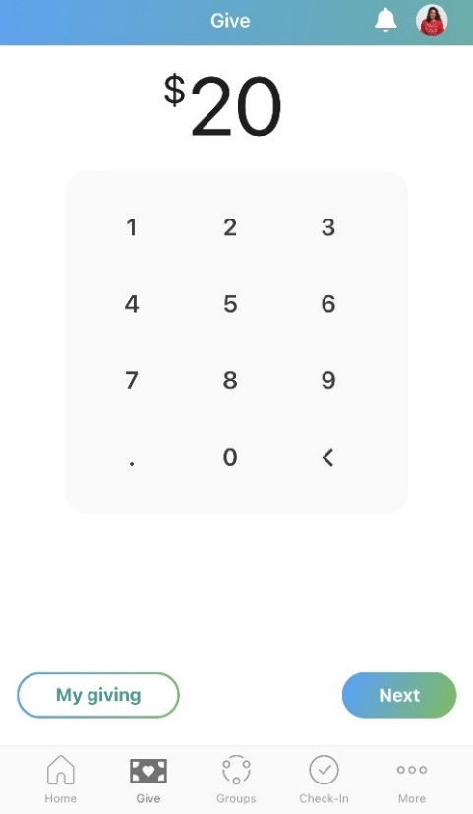

You can give a one-time gift or set up a recurring donation on the Giving page. Type the amount you want to donate and then select Next.

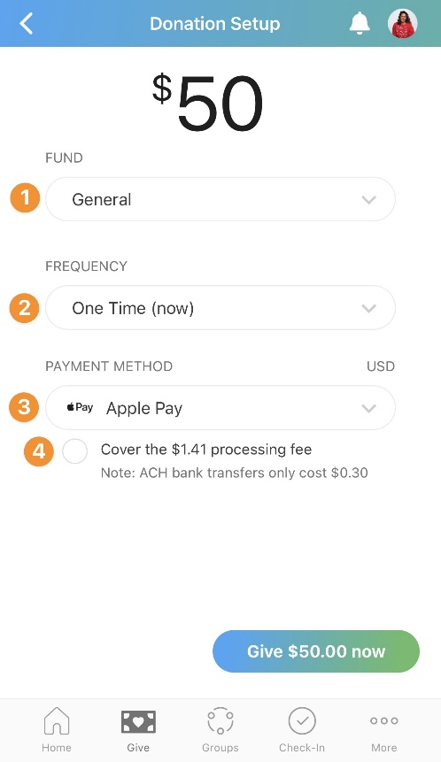
Next, set up your donation based on the desired fund, frequency, and payment method.
- Choose the fund you want to give to in the Church Center app.
Splitting your donations between multiple funds can only be set up on Church Center via our website. Please go to https://faithrexford.churchcenter.com/giving and click on the Give button.
- To set up a recurring donation, choose the frequency of the donation and the date that the recurring donation starts.
- Choose payment methods you've saved in the past, or add a new bank account or debit/credit card to complete your donation.
- Check the box if you want to cover the processing fee for the donation.

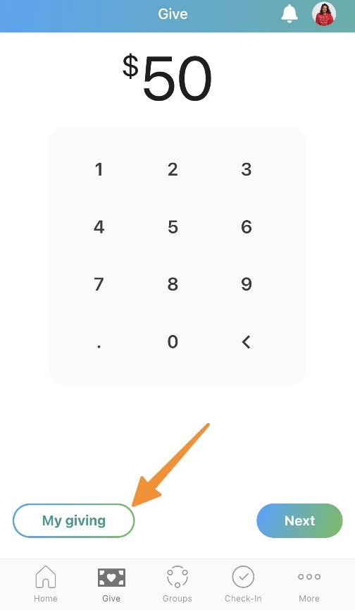
Update Your Giving Information
Church Center automatically creates a donor profile for you after you donate for the first time.
You can log in to your donor profile to update payment methods or recurring payments, view your donation history, access tax statements, and set communication preferences from the My Giving tab.
This tab can also be accessed from the Give page.
If you need to change the payment method used for Text2Give, you can do so from the Text2Give tab on the web.

2. Giving Using the Faith Website
Please note that you can donate without logging in if you are giving on the Faith website or using a direct link provided by the Faith office.

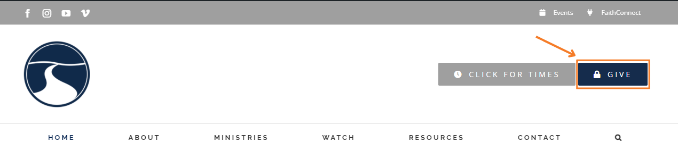

Select the navy “Give” button, to be taken directly to our Church Center giving page (pictured below).
To give to multiple funds, use the “+Add donation” button.
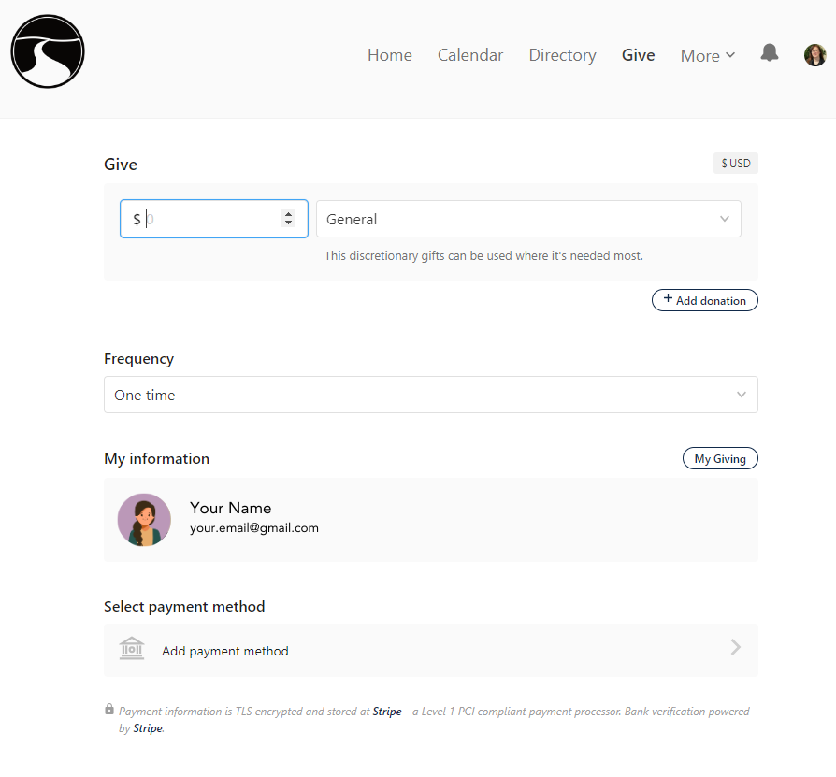

From here, you can select to give one time, or another type of frequency.

3. Creating recurring payments:
- Under Frequency, select Regularly.
- Select an interval of giving (Weekly, Every other week, Monthly or Twice-Monthly).
- Select a day.
- Select the date for recurring giving to begin.
- Select or add a payment method.
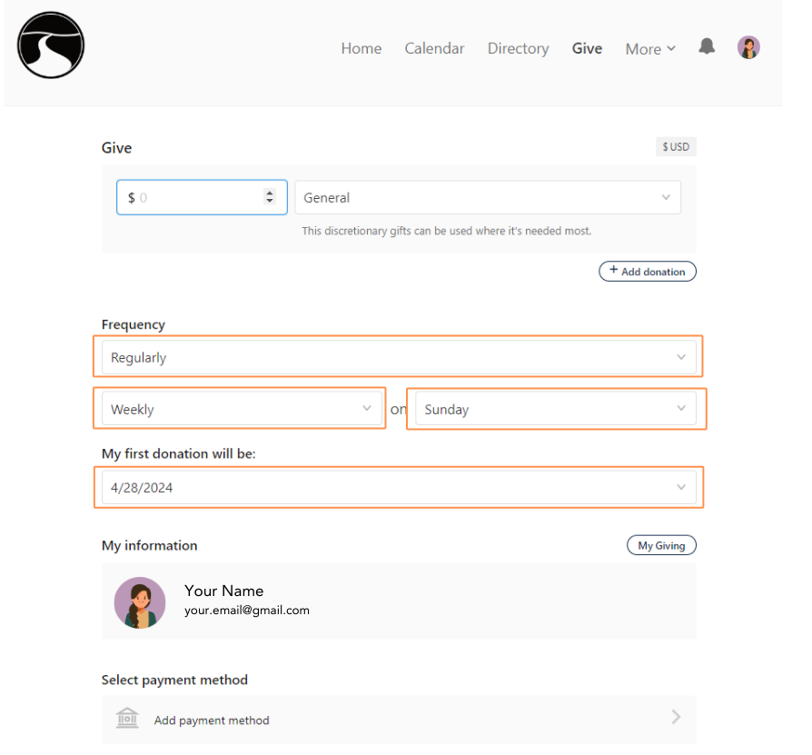
Available Payment Methods
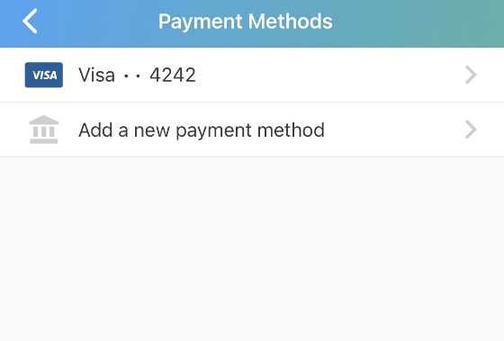
While donating, you can use one of the several payment methods available.
Choose from a previously saved payment method by logging into Church Center.
If you are not using a saved payment method for your donation, you can add a new bank account or add a debit/credit card.
Giving Using a Bank Account
Donors can verify and save their bank account to use when donating. The processing fees for donations given with a bank account are lower than those with a credit card; however, the funds will take four business days to get to your church.
When giving with a bank account for the first time, you must verify that you own the bank account. After that, your account will be saved to your donor profile, so you won't have to verify account ownership every time you give.
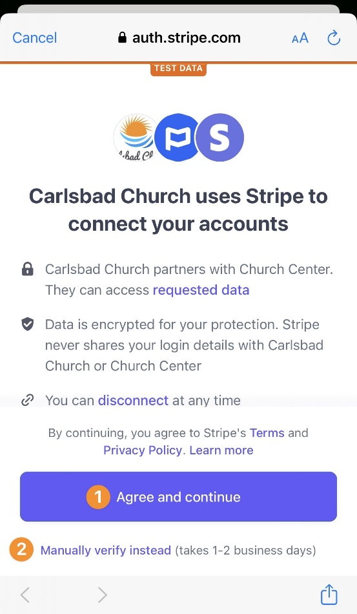
Select Add a new payment method, select US Bank Account, and select Agree and continue. Then, choose your desired verification method.
- Initiate instant verification, which allows you to donate that same day. Accounts with most major banks can be verified instantly.
- If your bank account is unavailable for instant verification, you must manually verify the account. Manual verification uses micro-deposits to verify your account and might take a few days to complete.
With manual micro-deposit verification, the bank deposits $0.01 into your account. Attached to the deposit is a six-character SM-code that must be entered into the Payment Methods tab of your Church Center profile to complete the verification process.
If you're having trouble verifying your savings account, try using your checking account instead.
Once your bank account is verified, you can donate using that payment method.
Giving Using a Debit/Credit Card
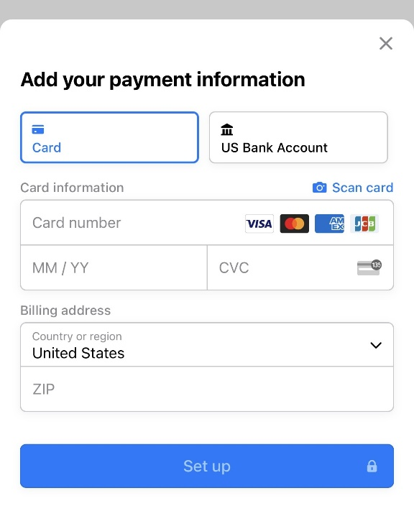
You can give using most major debit/credit cards, though your church has the option to disable credit card giving. If credit cards are disabled, you can still give using a debit or pre-paid card.
Select Add a new payment method, select card, and enter your card number, expiration date, CVC code, and billing address.
In the Church Center app, your card information will be automatically saved. On the web, you'll have the option to save your card to your donor profile.

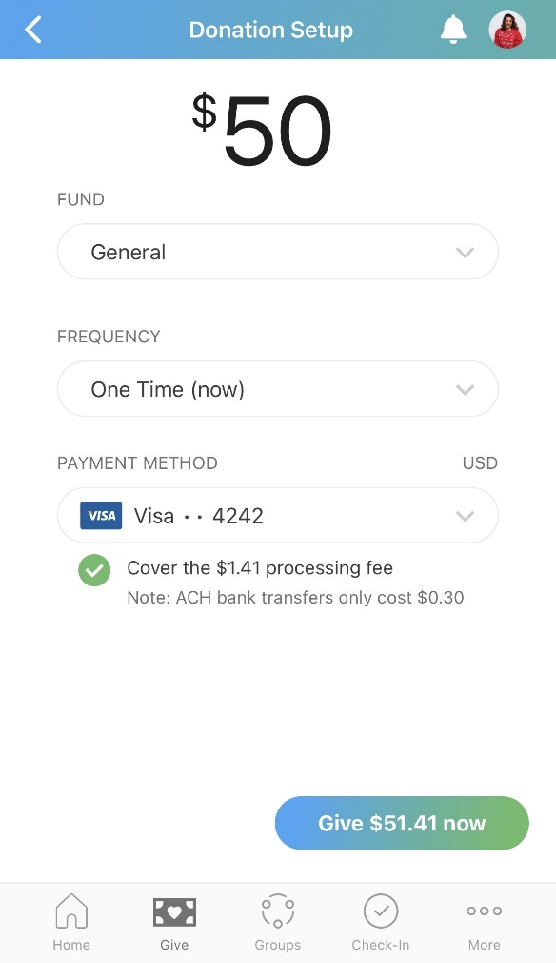

Check the box if you want to cover the processing fee, and then select Give now.

Editing Recurring Donations
Donors can edit recurring donations by clicking on the My Giving button on either the webpage or the mobile app. (You will need to log into your donor profile on Church Center, if you were not automatically logged in.)

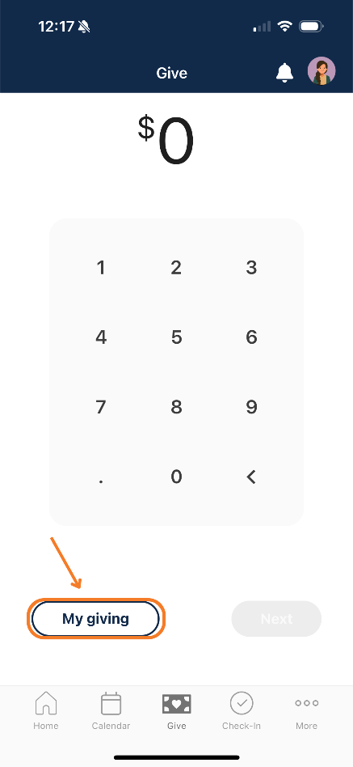
Webpage: Mobile App:
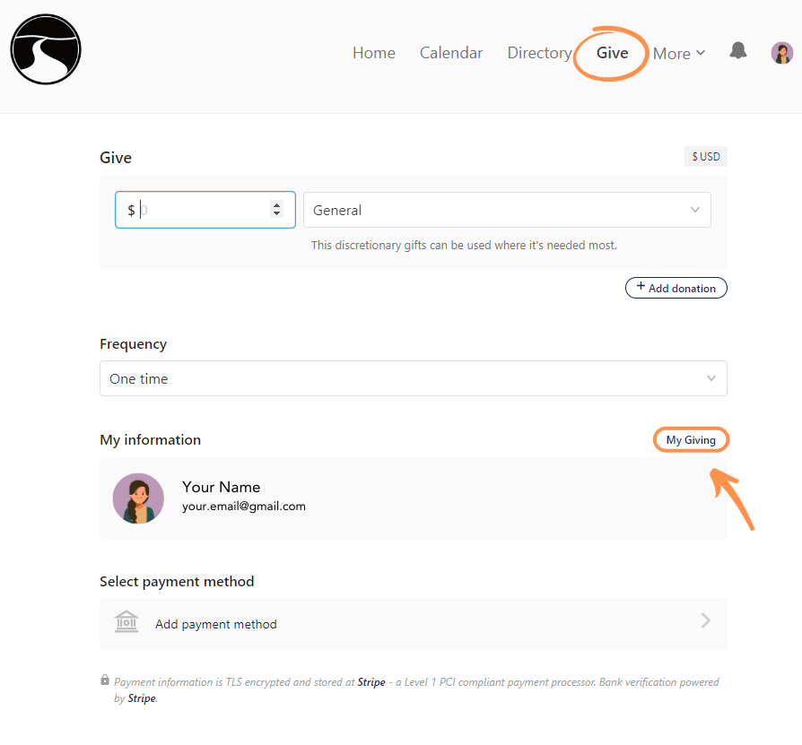

After clicking on the My Giving button, you will be taken to the My Giving Page (shown on next page). Click on Recurring Donations to view currently recurring donations or to set up a new recurring donation.

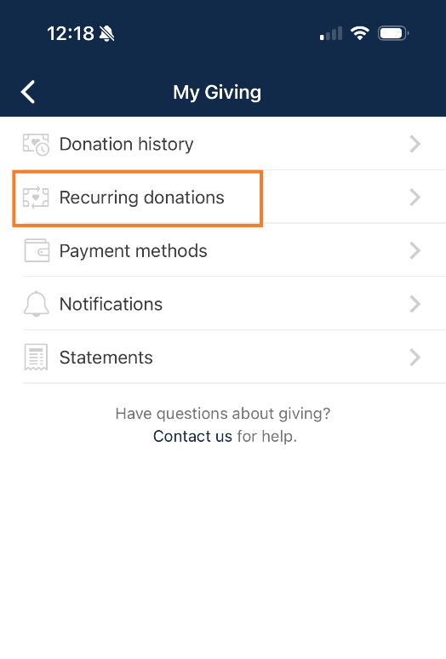
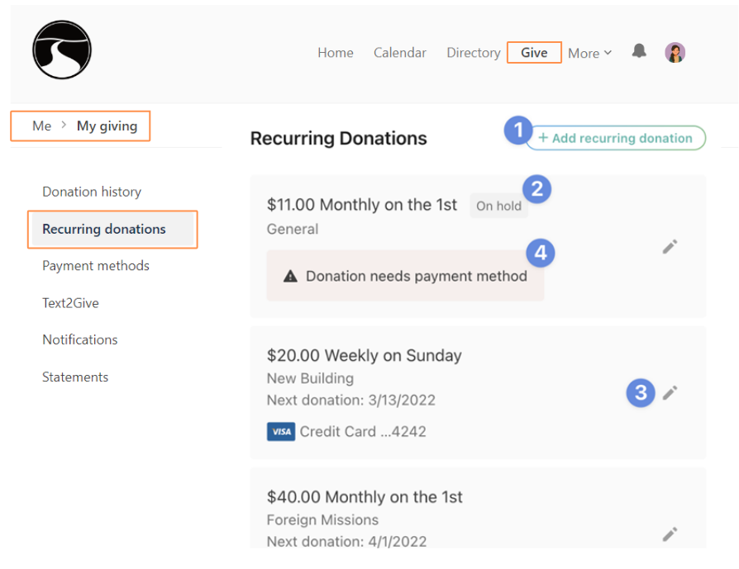
Webpage: Mobile App:

From the Recurring Donations page, you can:
- Add new recurring donations.
- View the status of existing donations.
- Edit a recurring donation's payment method or frequency. Donors can also put recurring donations on hold temporarily, permanently, or delete them altogether.
- See notifications about issues with a recurring donation.
- The donor can only update the recurring amount from the Church Center mobile app, but more options are available by going to the Giving page on our website.

Recurring Donation Failures
A recurring donation may fail for a number of reasons, such as:
- The account has insufficient funds.
- The card is invalid.
- The payment method was removed.
- The donor's own bank rejects the transaction.
If there's a problem processing a donation, a notification will be sent to the donor. Any Administrators who have those notifications enabled in their profile will also be alerted.
The system will not automatically retry the donation for the date it failed. It will, however, attempt the same donation on the next scheduled date.

After receiving a failure message, donors can click the link in the failure message to log into their profile and do any of the following:
- Fix the issue (which usually means updating the payment method).
- Put the donation on hold.
- Delete the recurring donation.
If a donor fixes the issue and they'd like to recover a failed donation, they can create a one-time donation for that month.

